**Question 1’s ,Answer:**

def checkpass(password):

upper_alp="QWERTYUIOPASDFGHJKLZXCVBNM"

lower_alp="qwertyuiopasdfghjklzxcvbnm"

number_1="1234567890"

special_char="!@#$%^&*()"

if len(password)<8:

return False

if not any(char in upper_alp for char in password):

return False

if not any(char in lower_alp for char in password):

return False

if not any(char in number_1 for char in password):

return False

if not any(char in special_char for char in password):

return False

return True

print(checkpass("Naveenraj@123"))

**output screen shot:**

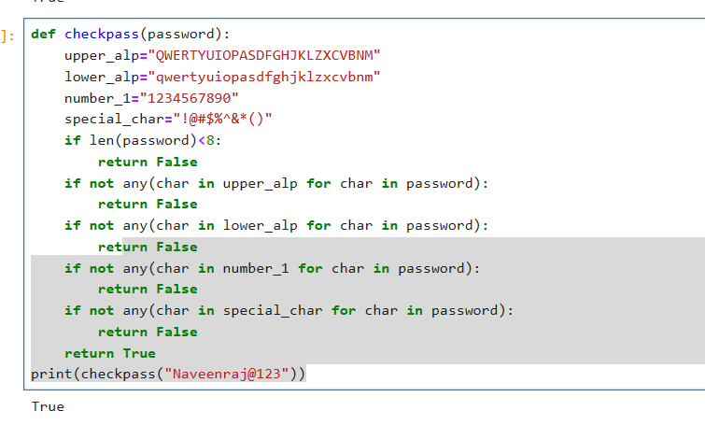

**Question 2’s answer:**

def attendance(record):

record_1=record.count('P')

record_2=(record_1/10)

if record_2>=0.7:

return('not suspended',record_2)

else:

return('suspended',record_2)

print(attendance('P A A P A A A A P P'))

**output evidence:**

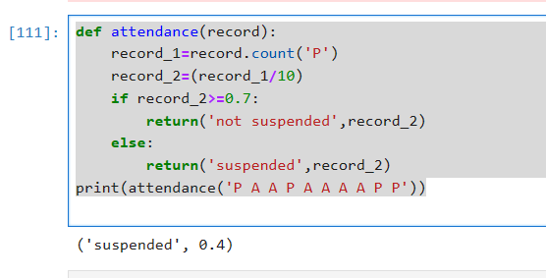

**Question 3’s answers:**

def ankit_max(marks_dict):

if len(marks_dict)<2:

return None

sort_marks=sorted(marks_dict.values(),reverse=True)

first_marks=sort_marks[0]

second_marks=sort_marks[1]

if first_marks==second_marks:

return None

for students,marks in marks_dict.items():

if marks==second_marks:

return students

print(ankit_max({'Alok': 10, 'Bikash': 24, 'Chandan': 26, 'Dali': 28, 'Eli': 30}))

**output evidence:**

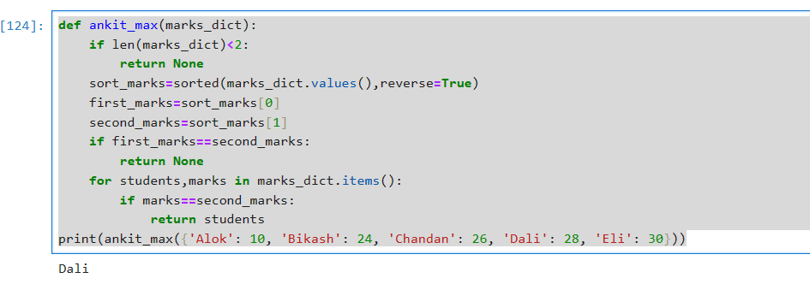

def ankit_max(marks_dict):

if len(marks_dict)<2:

return None

sort_marks=sorted(marks_dict.values(),reverse=True)

first_marks=sort_marks[0]

second_marks=sort_marks[1]

if first_marks==second_marks:

return None

for students,marks in marks_dict.items():

if marks==second_marks:

return students

print(ankit_max({'Xavier': 25, 'Ibrahim': 25, 'Yatin': 25, 'Sami': 25, 'Takahashi': 25}))

**output evidence:**

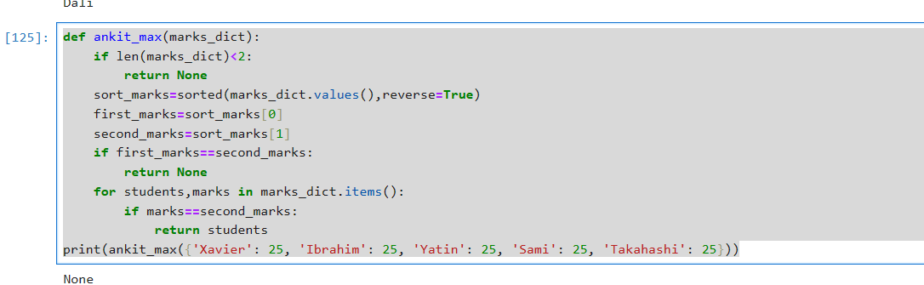

**Question 4’s answer:**

def multiple_of_3(number):

number_1=str(number)

update_num=[int(digi) for digi in number_1]

sum_num=sum(update_num)

if sum_num%3==0:

return True

else:

return False

print(multiple_of_3(124))

**output evidence:**

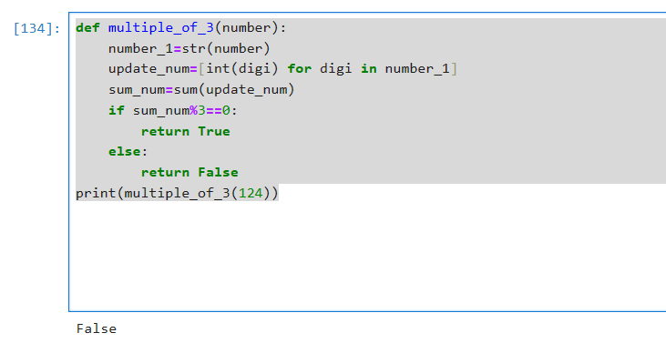

**Question 4’s answer:**

def multiple_of_3(number):

number_1=str(number)

update_num=[int(digi) for digi in number_1]

sum_num=sum(update_num)

if sum_num%3==0:

return True

else:

return False

print(multiple_of_3(123))

**output evidence:**

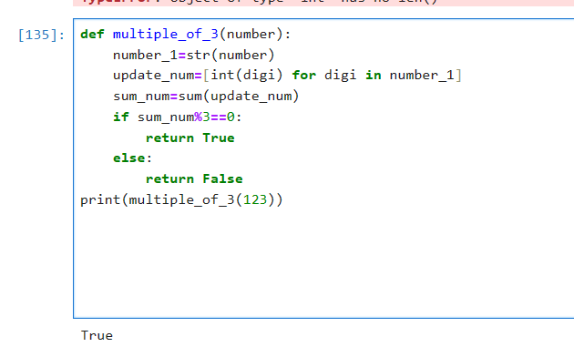

**Question 5’s answer**

def deduplicate(arg):

output_value=''

previous_value=None

for char in arg:

if char!=previous_value:

output_value+=char

previous_value=char

return output_value

arg=input()

result=deduplicate(arg)

print(result)

**ouput evidence:**

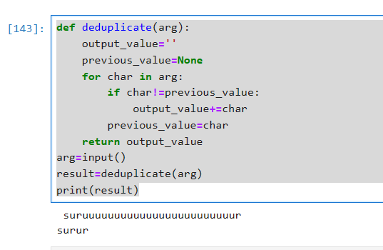

**ouput evidence:**

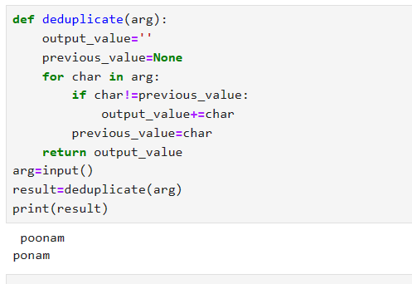

**ouput evidence:**

